Experiment 5: Hive and HiveQL

Steps:

1. Start Hadoop daemons:

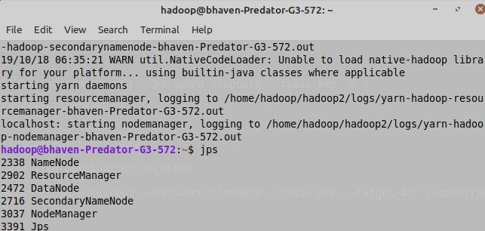

1. Create a new database and table in sql and insert some data in the table:

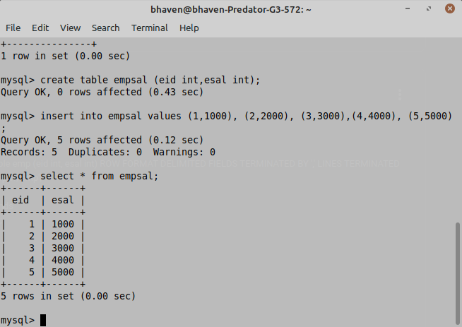

1. Import data into hdfs using sqoop:

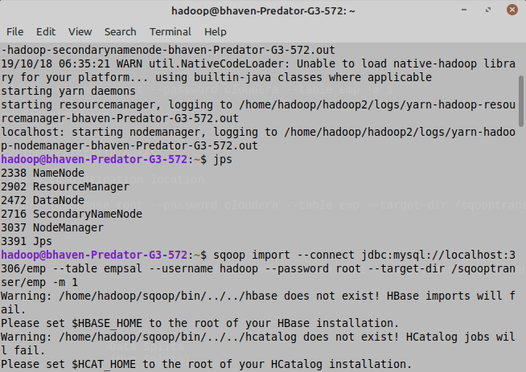

1. Load recently imported hdfs data into hive and perform analysis:

